**IDEATION TOOL**

**DESIGN DOCUMENT**

People can upload their creative ideas on the area of their expertise, where people can rate the ideas and talk about feasibility, implementation and work required.

We intend to bring people together to do things together which could solve or create simplest idea which can be implemented in real life.

Users: collection to store user records i.e. name, username, passwords, categories and email.

Posts: collection to share posts which a user has posted once approved by admin. Also store comments related to posts. Embedded document concept of mongodb.

AdminPosts: once a user post an idea it first comes here and admin approves it and then it goes to Posts.

Admin Categories: The categories which admin can add and user can select from that.

**In Scope (Phase I completed)**

* Registration and Login
* Posts (verification, updating, counts, rules, category )
* Comment on the posts.
* Add categories according to user interest.
* Admin can approve or disapprove idea within 7 days.

**Things that can be added (Phase II)**

* Forgot Password Implementation
* Star Rating ranging 1 to 5
* Option of upvote and downvote
* Top Rated Ideas on DashBoard first
* Filtering of ideas on the basis of past 1 week, 1 month or 6 month
* Archives can be save on DataBase to keep a backup.

**REQUIREMENT DOCUMENT**

Technologies: Node.js

Web Languages: HTML, CSS, Bootstrap, JavaScript

Database: MongoDB

Services: Heroku

**USER MANUAL/CONFIGURATION DOCUMENT**

Download node.js add link and configure mongodb database.

<https://nodejs.org/en/download/>

<https://www.mongodb.com/download-center>

The project repository is on the below mention link:

<https://github.com/CSC-ORG/JP--Ideation>

The project is live on the below mention link:

<http://zirine.herokuapp.com>

**FINAL REPRESENTATION OF THE PROJECT**

**REGISTERATION AND LOGIN**

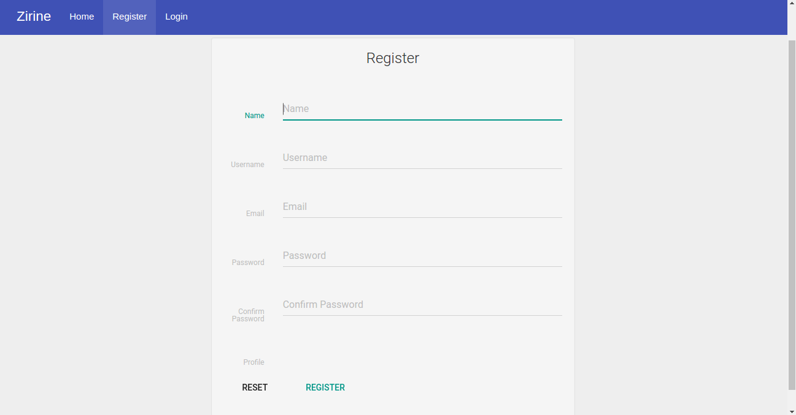

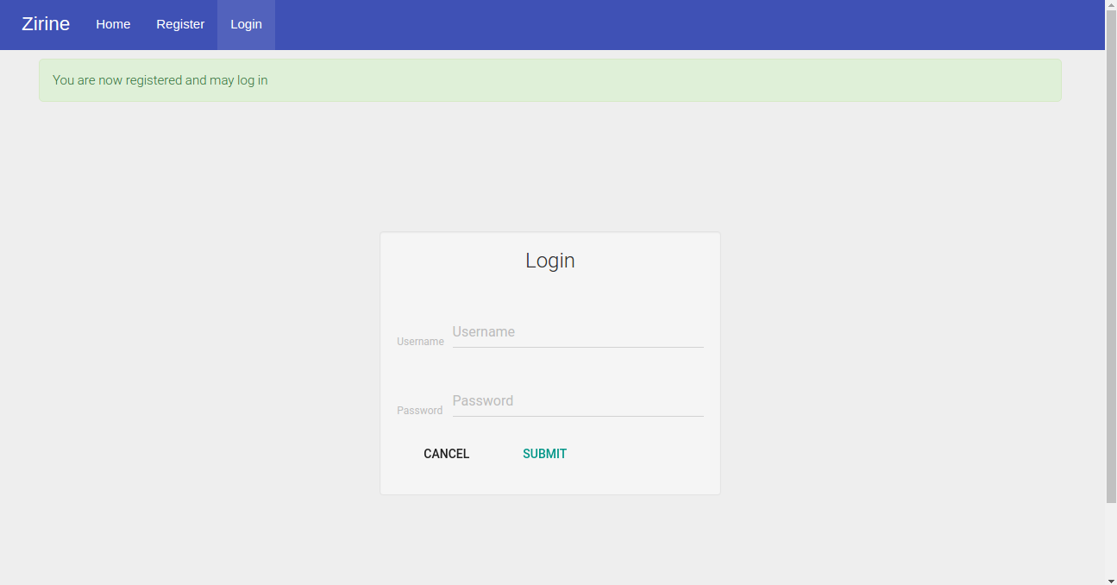

**ADMIN**

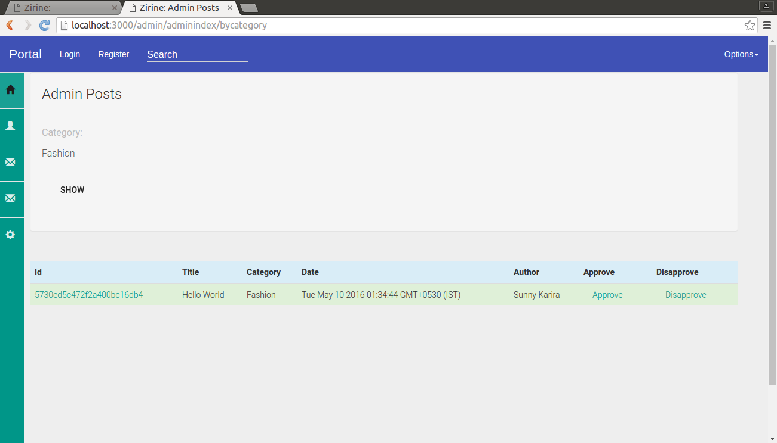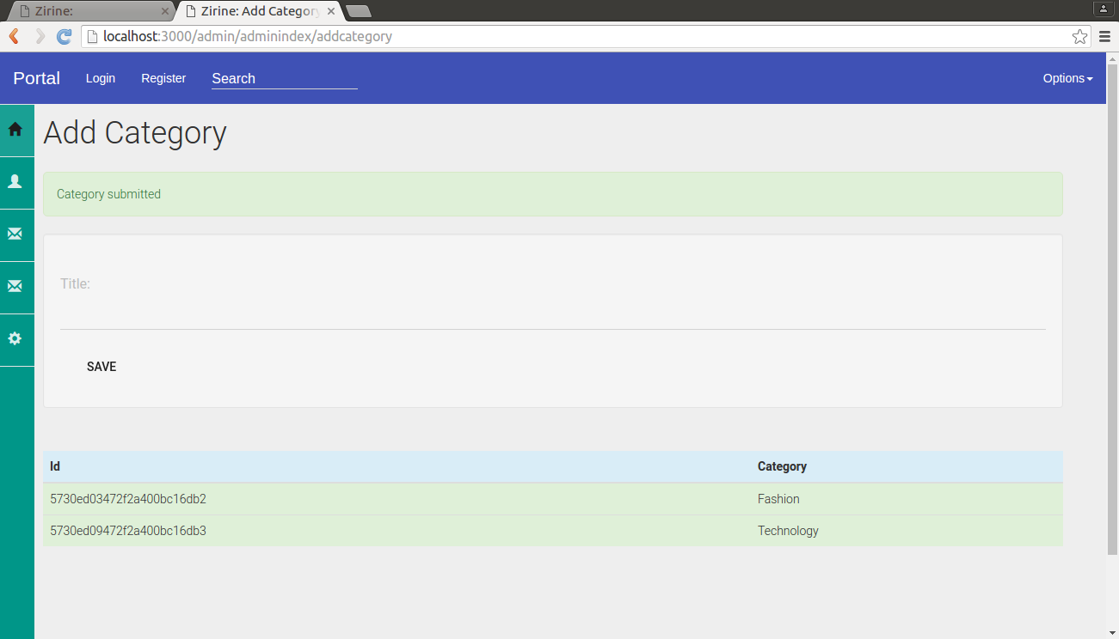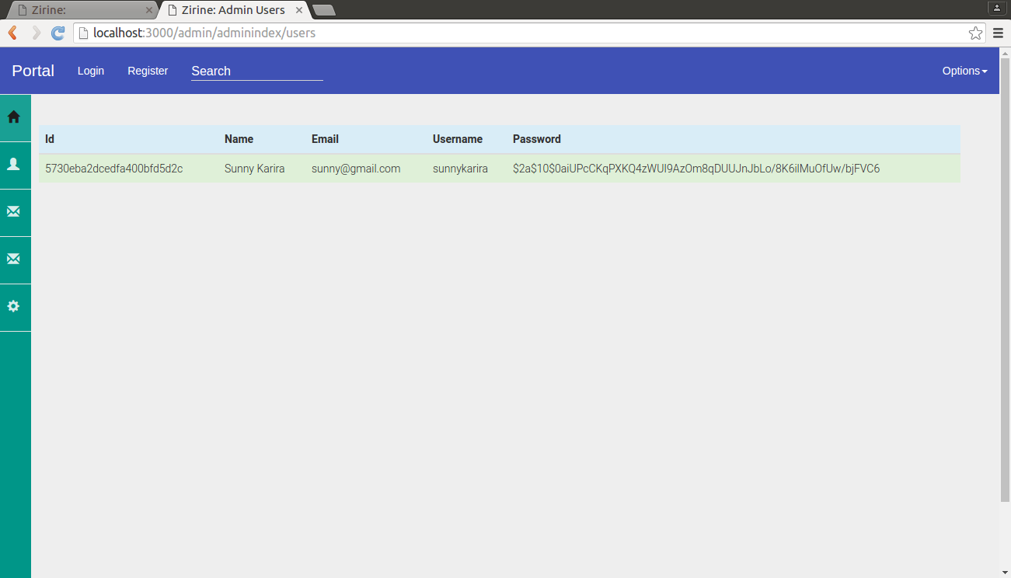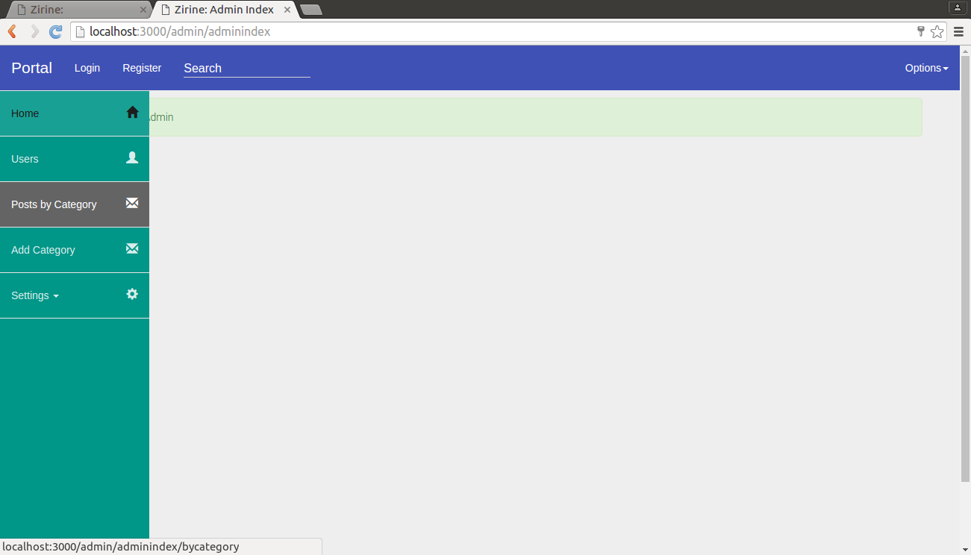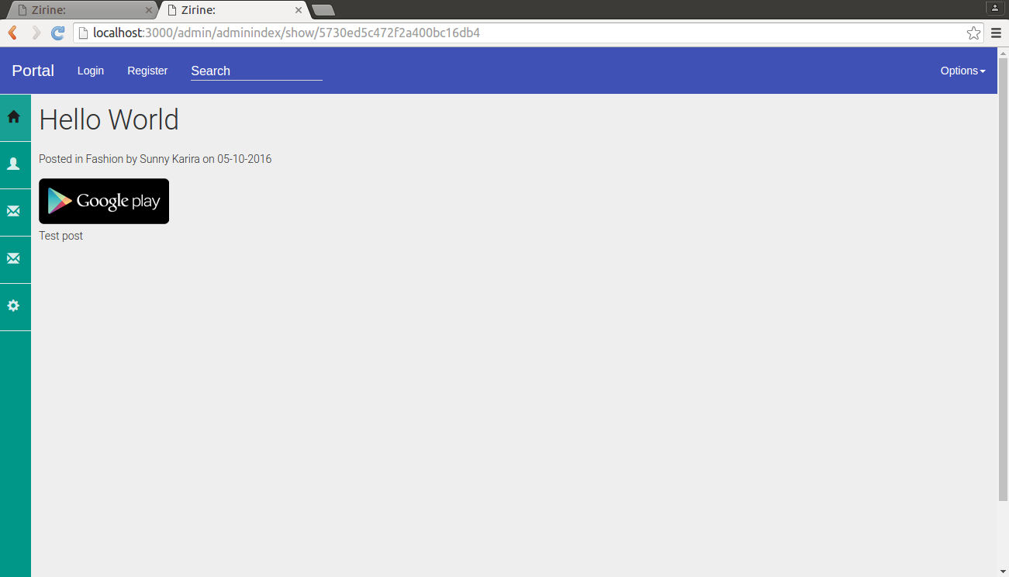

**USER**

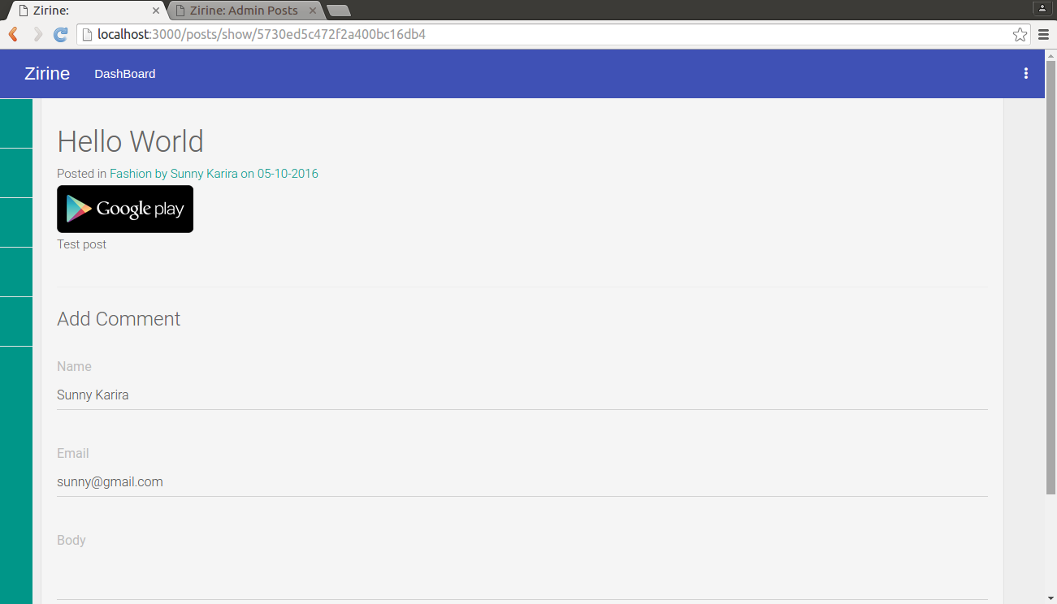

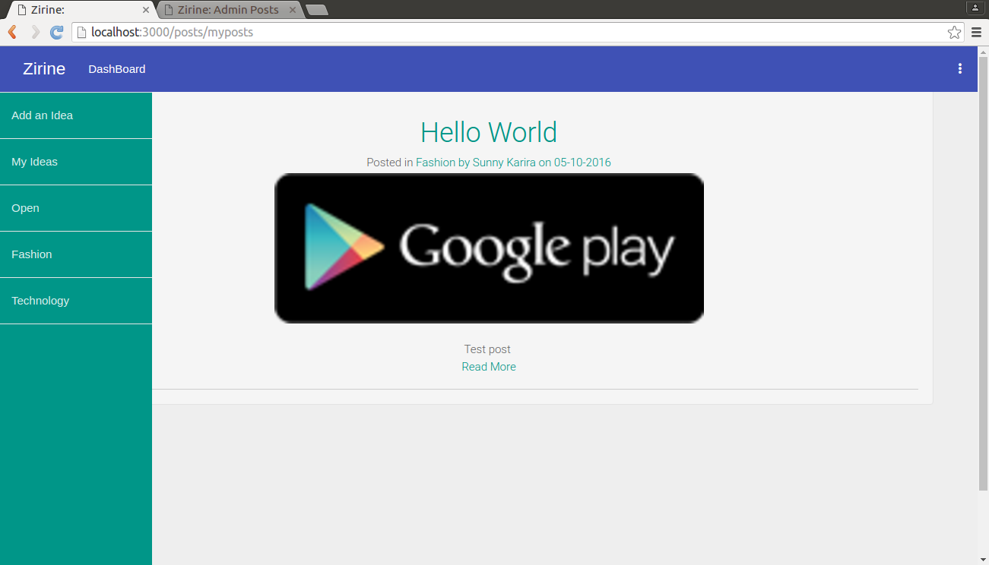

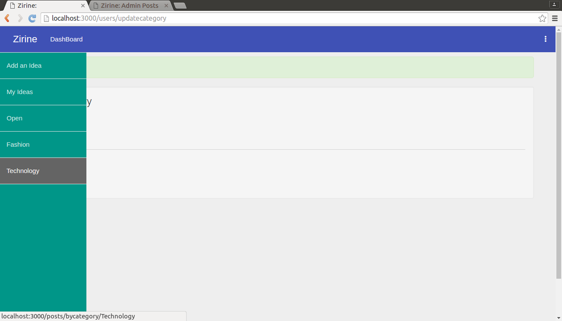

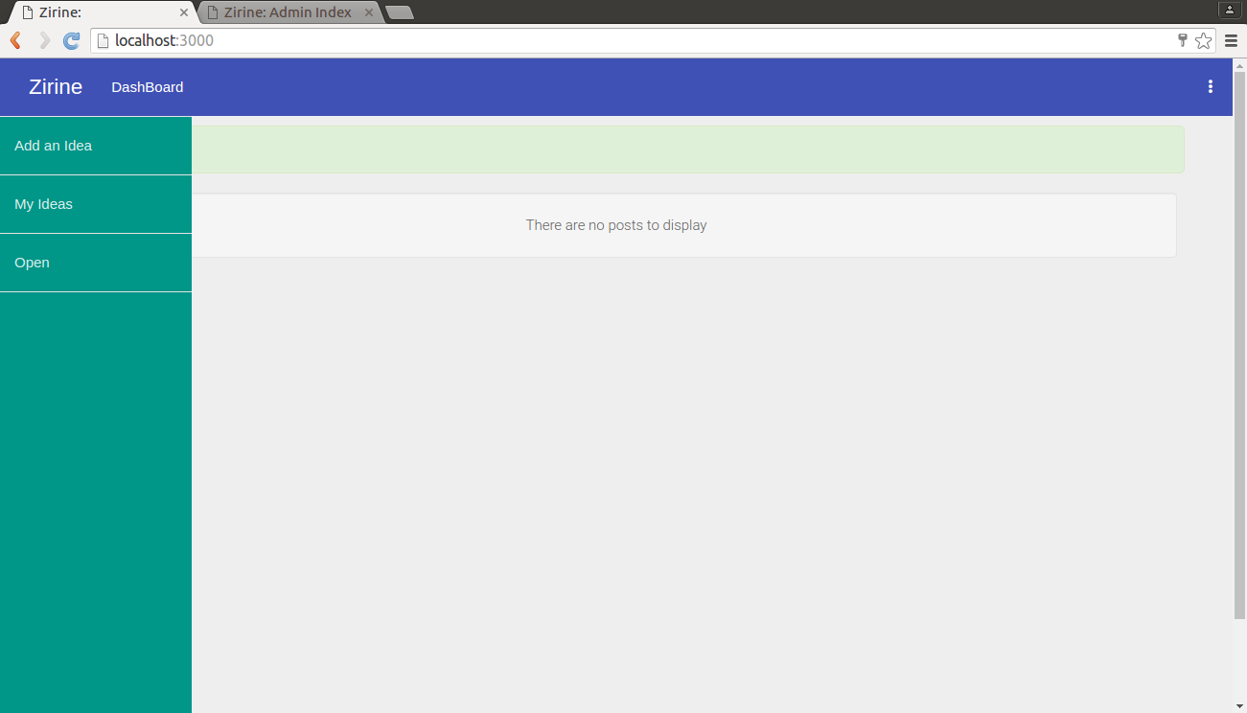

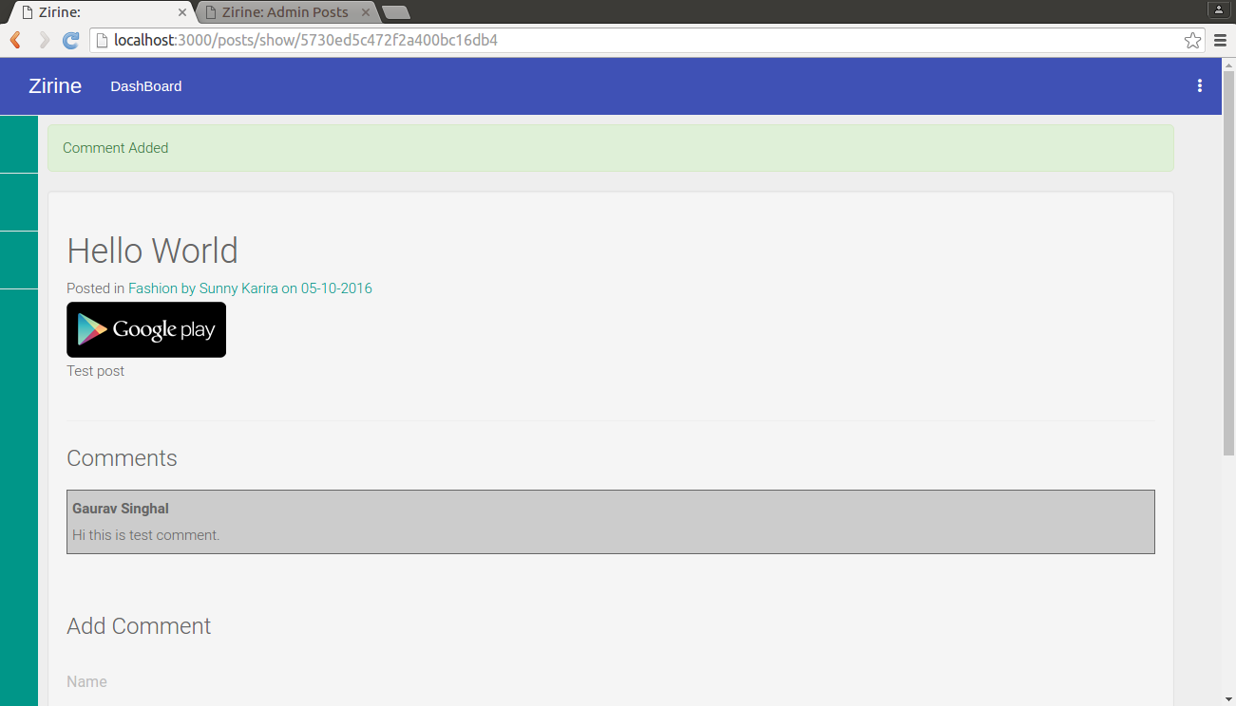

**TEST SCENARIOS/CASES**

|  |  |  |  |
| --- | --- | --- | --- |
| TEST NAME | DESCRIPTION | TEST | REPORT OF TEST |
| LOGIN | Registration and Login | Registration and Login successful | **PASS** |
| POSTS | User can post an idea according to his selected interest/categories. | User can post an idea according to his selected interest/categories successfully. | **PASS** |
| COMMENTS | User can comment on published ideas | User can comment on published ideas successfully. | **PASS** |
| ADMIN DECISION | Admin can approve or disapprove ideas within 7 days | Admin can approve or disapprove ideas within 7 days successfully. | **PASS** |
|  |  |  |  |